

Faculty of Engineering

Mechanical Department

[Mechatronics Program]

# “ Microprocessor & Microcontroller "

CODE: _ELC252_____

PROJECT REPORT

PROJECT: ____SMART HOME____

GROUP:______________



NAME

Omar khaled hassan mohamed ID:2022006780

# Objective:

# The objective of a smart home is to provide home automation and control through the use of interconnected devices that can be managed remotely via a centralized system. This system allows for the automation of various household functions, such as lighting, heating, security, and entertainment, to provide greater convenience, comfort, and energy efficiency for the homeowner. Smart homes can also be integrated with voice assistants and mobile applications for easy and intuitive control. The ultimate goal is to create a more connected, efficient, and personalized living experience for thehomeowner

# Components

## **1.DHT11–Temperature and Humidity Sensor**

### **2.RFID** (Radio-frequency identification

### 3. **HC-5 - Bluetooth Module**

## 4.Buzzer

## 5.Stm32f

## 6.Debuger

## 7. Dc motor

## 8.3leds color

## **1-DHT–Temperature and Humidity Sensor**

[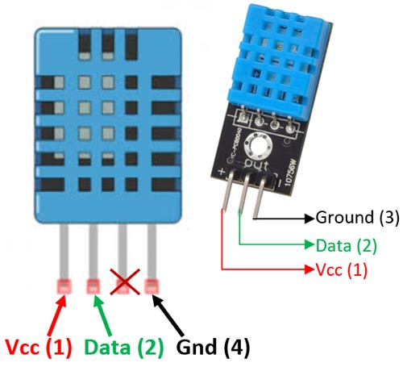](https://components101.com/sites/default/files/component_pin/DHT11%E2%80%93Temperature-Sensor-Pinout.jpg)

# The **DHT11**is a commonly used **Temperature and humidity sensor that** comes with a dedicated NTC to measure temperature and an 8-bit microcontroller to output the values of temperature and humidity as serial data.

|  |  |  |
| --- | --- | --- |
| **No:** | **Pin Name** | **Description** |
| **DHT11 Sensor module** | | |
| 1 | Vcc | Power supply 3.5V to 5.5V |
| 2 | Data | Outputs both Temperature and Humidity through serial Data |
| 3 | Ground | Connected to the ground of the circuit |

# **DHT11 Specifications**

## Operating Voltage: 3.5V to 5.5V

## Operating current: 0.3mA (measuring) 60uA (standby)

## Output: Serial data

## Temperature Range: 0°C to 50°C

## Humidity Range: 20% to 90%

## Resolution: Temperature and Humidity both are 16-bit

## Accuracy: ±1°C and ±1%

## **2-RFID** (Radio-frequency identification)

# 

|  |  |  |
| --- | --- | --- |
| **Pin Number** | **Pin Name** | **RC522 Pin Configuration** |
| 1 | VCC | Used to supply power (3.3V) to the module. |
| 2 | RST | Used to reset or power down the module. Hard power-down would be activated when this pin goes low. |
| 3 | GND | Ground pin, connected to the GND system of Arduino |
| 4 | IRQ | The interrupt pin is used to alter the [**MCU**](https://www.easybom.com/blog/a/microprocessor-vs-microcontroller-what-is-the-difference) as soon as the RFID tag shows up in its section. |
| 5 | MISO/SCL/Tx | It functions as SCL for the I2C interface and Tx for the UART interface in SPI communication. |
| 6 | MOSI | The Master Out Slave In pin is set to input for SPI communication. |
| 7 | SCK | It provides a clock source for the SPI bus Master (e.g. Arduino). |
| 8 | SS/SDA/Rx | It functions as SS (Serial input) during SPI communication, SDA for IIC, and Rx in UART. |

# **What is RFID Technology?**

## RFID (Radio Frequency Identification) technology is a communication technology that can identify specific targets and read and write relevant data through radio signals without the need to establish mechanical or optical contact between the identification system and specific targets.

## 

## An RFID system consists of two components: a tag or label and a reader. RFID tags or labels contain both a transmitter and a receiver. The RFID component on the tags is made up of two parts: a microchip that stores and processes data, and an antenna that receives and transmits signals. The tag contains the unique serial number for a single object.

## 

## To read the information encoded on a tag, a two-way radio transmitter-receiver known as an interrogator or reader uses an **antenna** to send a signal to the tag. The tag responds with the data stored in its memory bank. The read results will then be transmitted to an RFID computer program by the interrogator

## RFID working diagram3-**HC-05 - Bluetooth Module**

[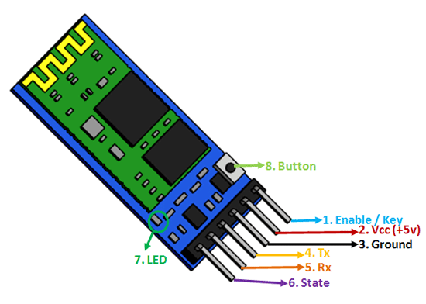](https://components101.com/sites/default/files/component_pin/HC-05-Bluetooth-Module-Pinout.png)

## The HC-05 is a popular bluetooth module which can add two-way (full-duplex) wireless functionality to your projects

|  |  |  |
| --- | --- | --- |
| **Pin Number** | **Pin Name** | **Description** |
| 1 | Enable / Key | This pin is used to toggle between Data Mode (set low) and AT command mode (set high). By default it is in Data mode |
| 2 | Vcc | Powers the module. Connect to +5V Supply voltage |
| 3 | Ground | Ground pin of module, connect to system ground. |
| 4 | TX – Transmitter | Transmits Serial Data. Everything received via Bluetooth will be given out by this pin as serial data. |
| 5 | RX – Receiver | Receive Serial Data. Every serial data given to this pin will be broadcasted via Bluetooth |
| 6 | State | The state pin is connected to on board LED, it can be used as a feedback to check if Bluetooth is working properly. |
| 7 | LED | Indicates the status of Module   * Blink once in 2 sec: Module has entered Command Mode * Repeated Blinking: Waiting for connection in Data Mode * Blink twice in 1 sec: Connection successful in Data Mode |
| 8 | Button | Used to control the Key/Enable pin to toggle between Data and command Mode |

## **HC-05 Default Settings**

## Default Bluetooth Name: “HC-05”

## Default Password: 1234 or 0000

## Default Communication: Slave

## Default Mode: Data Mode

## Data Mode Baud Rate: 9600, 8, N, 1

## Command Mode Baud Rate: 38400, 8, N, 1

## Default firmware: LINVOR

## 

# **HC-05 Technical Specifications**

## Serial Bluetooth module for Arduino  and other microcontrollers

## Operating Voltage: 4V to 6V (Typically +5V)

## Operating Current: 30mA

## Range: <100m

## Works with Serial communication (USART) and TTL compatible

## Follows IEEE 802.15.1 standardized protocol

## Uses Frequency-Hopping Spread spectrum (FHSS)

## Can operate in Master, Slave or Master/Slave mode

## Can be easily interfaced with Laptop or Mobile phones with Bluetooth

## Supported baud rate: 9600,19200,38400,57600,115200,230400,460800

4-Stm32f103b1:

STM32 F1-series was the first group of STM32 microcontrollers based on theARM Cortex-M3 core and considered their mainstream ARM microcontrollers. The F1-series has evolved over time by increasing CPU speed, size of internal memory, variety of peripherals.There are five F1 lines: Connectivity (STM32F105/107), Performance (STM32F103), USB Access (STM32F102), Access (STM32F101), Value (STM32F100

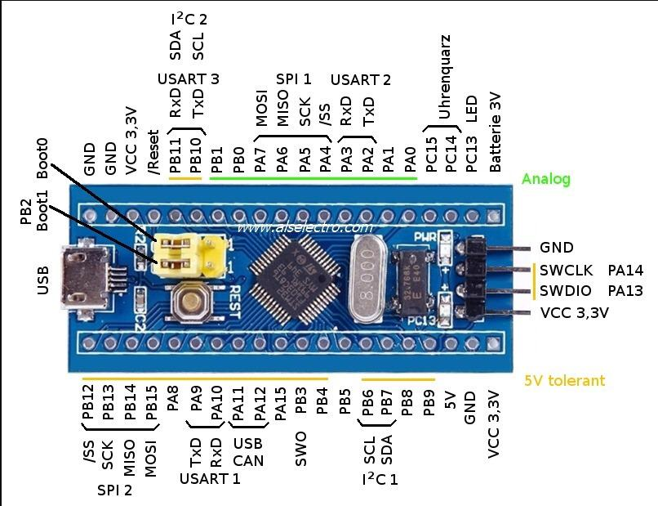

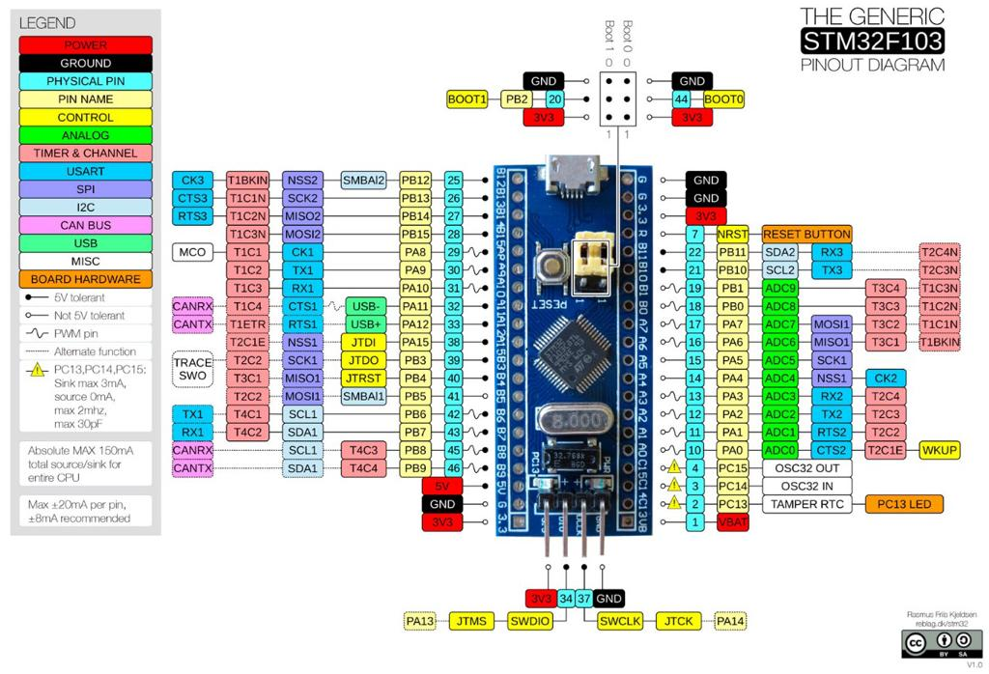to upload code is through SINGLE WIRE INTERFACE ModuleInterface (SWIM) .This uses only 2 wires SWCLK, SWDIO apart from power pins .You can see this as 4 separate header pins to the right end of module.You need a ST-LINK dongle or device to connect with the SWIM.

The ST-LINK/V2 is an in-circuit debugger/programmer for the STM8 and STM32 microcontrollers. The single wire interface module (SWIM) interfaces facilitate the communication with any STM8 or STM32 microcontroller operating on an application board

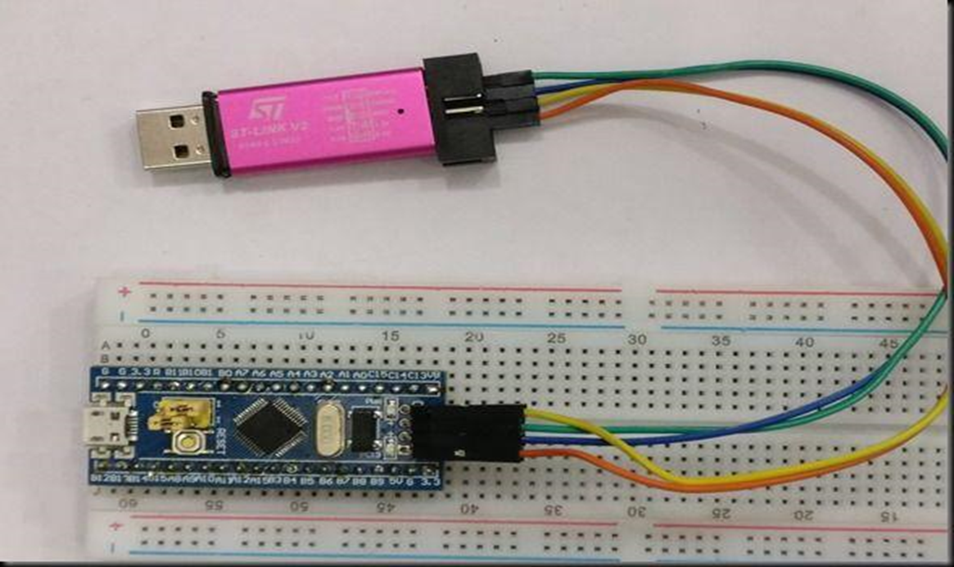

Flow char:

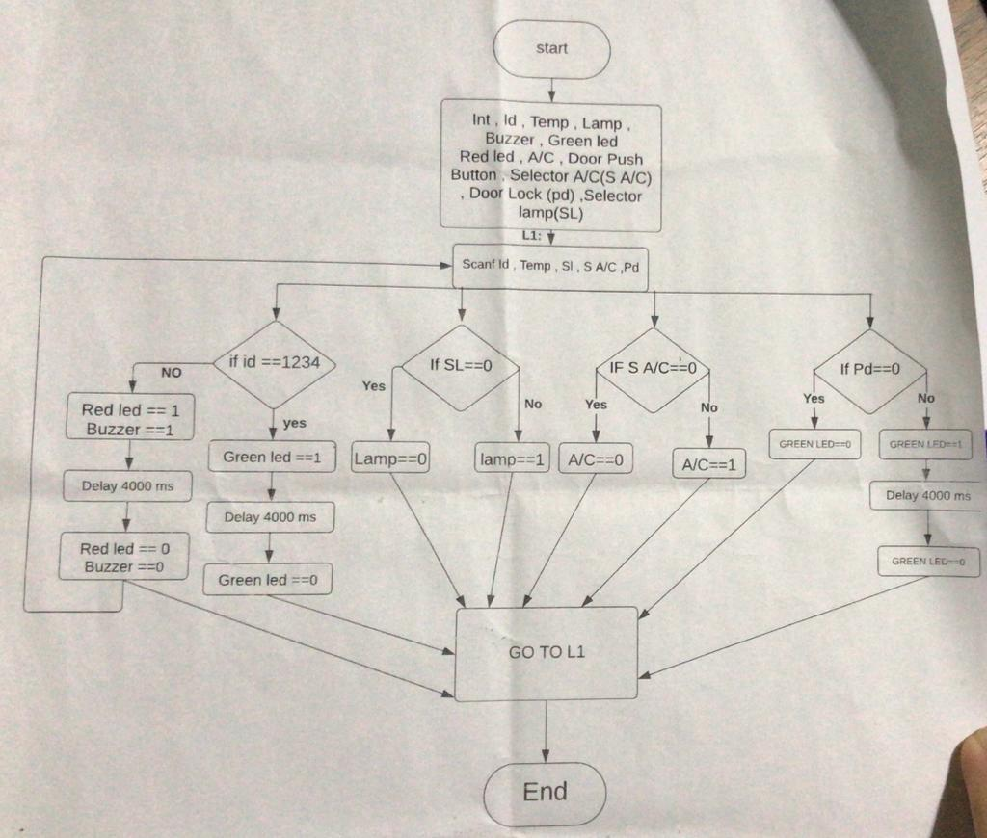

Circuit diagram:

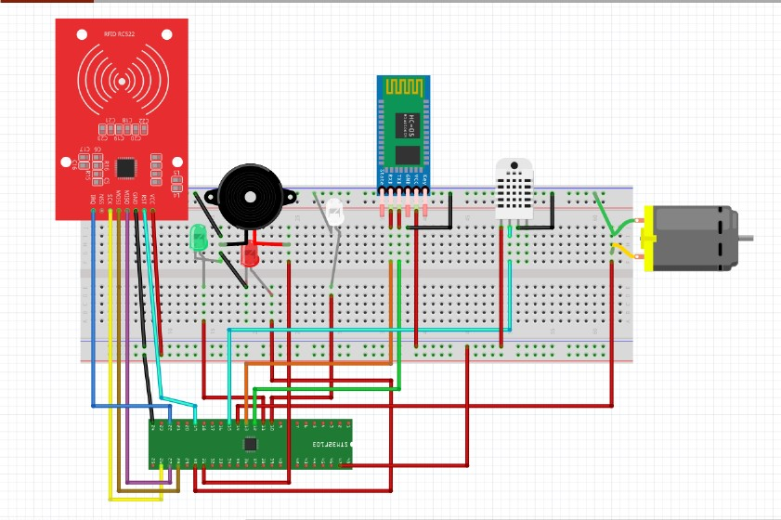

Code –C:

#include <DHT_U.H>

include <dht.h>

// RemoteXY select connection mode and include library

#define REMOTEXY_MODE__HARDSERIAL

#include <RemoteXY.h>

#include <DHT.h>

//initilize object dht for class DHT with DHT pin with STM32 and DHT type as DHT11

// RemoteXY connection settings

#define REMOTEXY_SERIAL Serial2

#define REMOTEXY_SERIAL_SPEED 9600

#define DHTPIN PA5

#define DHTTYPE DHT11

DHT dht(DHTPIN, DHTTYPE);

int t;//t=Temp

int h;//h=Humidity

int greenpin ;

int redpin ;

int buzzerpin ;

// RemoteXY configurate

#pragma pack(push, 1)

uint8_t RemoteXY_CONF[] = // 139 bytes

{ 255,3,0,22,0,132,0,16,31,1,2,0,24,7,22,11,12,26,31,31,

79,78,0,79,70,70,0,67,4,7,60,20,5,2,26,11,129,0,8,51,

18,6,17,84,101,109,112,0,129,0,2,33,26,6,17,108,111,99,107,32,

100,111,111,114,0,129,0,3,11,18,6,17,76,97,109,112,0,2,0,10,

76,22,11,12,26,31,31,79,78,0,79,70,70,0,129,0,12,68,18,6,

17,65,47,67,0,1,8,33,29,12,12,12,27,0,67,4,33,60,20,5,

2,26,11,129,0,33,50,18,6,17,104,117,109,105,100,105,116,121,0 };

// this structure defines all the variables and events of your control interface

struct {

// input variables

uint8_t lamp; // =1 if switch ON and =0 if OFF

uint8_t air_condition; // =1 if switch ON and =0 if OFF

uint8_t lock_door; // =1 if button pressed, else =0

// output variables

char text_Temp[11]; // string UTF8 end zero

char text_Humidity[11]; // string UTF8 end zero

// other variable

uint8_t connect_flag; // =1 if wire connected, else =0

} RemoteXY;

#pragma pack(pop)

//////switchs

#define PIN_LAMP PA0

#define PIN_AIR_CONDITION PA4

#define PIN_LOCK_DOOR PA1

///////DHT

//////////RFID

#include <SPI.h>

#include <MFRC522.h>

#define SS_PIN PB11

#define RST_PIN PB1

MFRC522 rfid(SS_PIN, RST_PIN); // Instance of the class

MFRC522::MIFARE_Key key;

// Init array that will store new NUID

byte nuidPICC[4];

#define greenpin PA1

#define redpin PA9

#define buzzerpin PA10

void setup()

{

////////DHT

Serial.begin(9600);

display.begin(SSD1306_SWITCHCAPVCC, 0x3C); // initialize with the

pinMode(DHTPIN, OUTPUT);

dht.begin();

/////

RemoteXY_Init ();

pinMode (PIN_LAMP, OUTPUT);

pinMode (PIN_AIR_CONDITION, OUTPUT);

pinMode (PIN_LOCK_DOOR, OUTPUT);

////ID locker

pinMode(greenpin, OUTPUT);

pinMode(redpin, OUTPUT);

pinMode(buzzerpin, OUTPUT);

Serial.begin(9600);

SPI.begin(); // Init SPI bus

rfid.PCD_Init(); // Init MFRC522

for (byte i = 0; i < 6; i++) {

key.keyByte[i] = 0xFF;

}

Serial.println(F("This code scan the MIFARE Classsic NUID."));

Serial.print(F("Using the following key:"));

printHex(key.keyByte, MFRC522::MF_KEY_SIZE);

}

// TODO you setup code

void loop()

{

RemoteXY_Handler ();

////switchs

digitalWrite(PIN_LAMP, (RemoteXY.lamp==0)?LOW:HIGH);

digitalWrite(PIN_AIR_CONDITION, (RemoteXY.air_condition==0)?LOW:HIGH);

digitalWrite(PIN_LOCK_DOOR, (RemoteXY.lock_door==0)?LOW:HIGH);

///////////DHT

h = dht.readHumidity(); //Gets Humidity value

t = dht.readTemperature(); //Gets Temperature value

dtostrf(t, 0, 1, RemoteXY.text_Temp);

dtostrf(h, 0, 1, RemoteXY.text_Humidity);

delay(1500);

///////ID LOcker

// Reset the loop if no new card present on the sensor/reader. This saves the entire process when idle.

if ( ! rfid.PICC_IsNewCardPresent())

return;

// Verify if the NUID has been readed

if ( ! rfid.PICC_ReadCardSerial())

return;

Serial.print(F("PICC type: "));

MFRC522::PICC_Type piccType = rfid.PICC_GetType(rfid.uid.sak);

Serial.println(rfid.PICC_GetTypeName(piccType));

// Check is the PICC of Classic MIFARE type

if (piccType != MFRC522::PICC_TYPE_MIFARE_MINI &&

piccType != MFRC522::PICC_TYPE_MIFARE_1K &&

piccType != MFRC522::PICC_TYPE_MIFARE_4K) {

Serial.println(F("Your tag is not of type MIFARE Classic."));

return;

}

if (rfid.uid.uidByte[0] != nuidPICC[0] ||

rfid.uid.uidByte[1] != nuidPICC[1] ||

rfid.uid.uidByte[2] != nuidPICC[2] ||

rfid.uid.uidByte[3] != nuidPICC[3] ) {

Serial.println(F("A new card has been detected."));

// Store NUID into nuidPICC array

for (byte i = 0; i < 4; i++) {

nuidPICC[i] = rfid.uid.uidByte[i];

}

Serial.println(F("The NUID tag is:"));

Serial.print(F("In hex: "));

printHex(rfid.uid.uidByte, rfid.uid.size);

Serial.println();

Serial.print(F("In dec: "));

printDec(rfid.uid.uidByte, rfid.uid.size);

Serial.println();

}

else Serial.println(F("Card read previously."));

if(nuidPICC[0] == 0x73 && nuidPICC[1]==0xBE && nuidPICC[2]==0xFC && nuidPICC[3]==0x00){

digitalWrite(greenpin , HIGH);

delay(4000);

digitalWrite(greenpin , LOW);

}

else{

digitalWrite(redpin,HIGH);

digitalWrite(buzzerpin, HIGH);

delay(4000);

digitalWrite(redpin,LOW);

digitalWrite(buzzerpin,LOW);

}

// Halt PICC

rfid.PICC_HaltA();

// Stop encryption on PCD

rfid.PCD_StopCrypto1();

}

// TODO you loop code

// use the RemoteXY structure for data transfer

// do not call delay(), use instead RemoteXY_delay()

void printHex(byte *buffer, byte bufferSize) {

for (byte i = 0; i < bufferSize; i++) {

Serial.print(buffer[i] < 0x10 ? " 0" : " ");

Serial.print(buffer[i], HEX);

}

}

/**

* Helper routine to dump a byte array as dec values to Serial.

*/

void printDec(byte *buffer, byte bufferSize) {

for (byte i = 0; i < bufferSize; i++) {

Serial.print(buffer[i] < 0x10 ? " 0" : " ");

Serial.print(buffer[i], DEC);

}

}

Code_assembly:

; Include libraries

#include <DHT.h>

#include <RemoteXY.h>

#include <SPI.h>

#include <MFRC522.h>

; Define constants

#define DHTPIN PA5

#define DHTTYPE DHT11

#define REMOTEXY_SERIAL Serial2

#define REMOTEXY_SERIAL_SPEED 9600

#define PIN_LAMP PA0

#define PIN_AIR_CONDITION PA4

#define PIN_LOCK_DOOR PA1

#define SS_PIN PB11

#define RST_PIN PB1

#define greenpin PA1

#define redpin PA9

#define buzzerpin PA10

; Initialize DHT object

DHT dht(DHTPIN, DHTTYPE);

; Define variables

int t; ; Temperature

int h; ; Humidity

int greenpin;

int redpin;

int buzzerpin;

; RemoteXY configuration

#pragma pack(push, 1)

uint8_t RemoteXY_CONF[] = ; 139 bytes

{ 255,3,0,22,0,132,0,16,31,1,2,0,24,7,22,11,12,26,31,31,

79,78,0,79,70,70,0,67,4,7,60,20,5,2,26,11,129,0,8,51,

18,6,17,84,101,109,112,0,129,0,2,33,26,6,17,108,111,99,107,32,

100,111,111,114,0,129,0,3,11,18,6,17,76,97,109,112,0,2,0,10,

76,22,11,12,26,31,31,79,78,0,79,70,70,0,129,0,12,68,18,6,

17,65,47,67,0,1,8,33,29,12,12,12,27,0,67,4,33,60,20,5,

2,26,11,129,0,33,50,18,6,17,104,117,109,105,100,105,116,121,0 };

; Define control interface structure

struct {

; Input variables

uint8_t lamp; ; =1 if switch ON and =0 if OFF

uint8_t air_condition; ; =1 if switch ON and =0 if OFF

uint8_t lock_door; ; =1 if button pressed, else =0

; Output variables

char text_Temp[11]; ; string UTF8 end zero

char text_Humidity[11]; ; string UTF8 end zero

; Other variable

uint8_t connect_flag; ; =1 if wire connected, else =0

} RemoteXY;

#pragma pack(pop)

; Initialize MFRC522 object

MFRC522 rfid(SS_PIN, RST_PIN); ; Instance of the class

MFRC522::MIFARE_Key key;

; Init array that will store new NUID

byte nuidPICC[4];

; Main program

void setup() {

; Initialize DHT sensor

dht.begin();

; Initialize RemoteXY

RemoteXY_Init();

; Initialize SPI communication

SPI.begin();

; Initialize MFRC522

rfid.PCD_Init();

}

void loop() {

; RemoteXY control

RemoteXY_Handler();

; Read DHT sensor

t = dht.readTemperature();

h = dht.readHumidity();

; Update RemoteXY variables

RemoteXY.text_Temp = t;

RemoteXY.text_Humidity = h;

; Check RFID card

if (rfid.PICC_IsNewCardPresent() && rfid.PICC_ReadCardSerial()) {

; Read card UID

for (byte i = 0; i < 4; i++) {

nuidPICC[i] = rfid.uid.uidByte[i];

}

}

}

; Assembly code for Arduino sketch

; Define constants

DHTPIN PA5

PIN_LAMP PA0

PIN_AIR_CONDITION PA4

PIN_LOCK_DOOR PA1

greenpin PA1

redpin PA9

buzzerpin PA10

; Initialize setup

setup:

call Serial_begin

call display_begin

mov r16, DHTPIN

out DDRB, r16 ; Set DHTPIN as output

call dht_begin

call RemoteXY_Init

mov r16, PIN_LAMP

out DDRB, r16 ; Set PIN_LAMP as output

mov r16, PIN_AIR_CONDITION

out DDRB, r16 ; Set PIN_AIR_CONDITION as output

mov r16, PIN_LOCK_DOOR

out DDRB, r16 ; Set PIN_LOCK_DOOR as output

mov r16, greenpin

out DDRB, r16 ; Set greenpin as output

mov r16, redpin

out DDRB, r16 ; Set redpin as output

mov r16, buzzerpin

out DDRB, r16 ; Set buzzerpin as output

call Serial_begin

call SPI_begin

call PCD_Init

ldi r16, 0xFF

ldi r17, 0

init_loop:

st Z+, r16 ; Initialize key.keyByte with 0xFF

inc r17

cpi r17, 6

brne init_loop

call print_key_info

ret

; Main loop

loop:

call RemoteXY_Handler

lds r16, RemoteXY_lamp

cpi r16, 0

breq lamp_off

rjmp lamp_on

lamp_off:

ldi r16, 0

out PORTB, r16 ; Turn off PIN_LAMP

rjmp air_condition_check

lamp_on:

ldi r16, 1

out PORTB, r16 ; Turn on PIN_LAMP

air_condition_check:

lds r16, RemoteXY_air_condition

cpi r16, 0

breq air_condition_off

rjmp air_condition_on

air_condition_off:

ldi r16, 0

out PORTB, r16 ; Turn off PIN_AIR_CONDITION

rjmp lock_door_check

air_condition_on:

ldi r16, 1

out PORTB, r16 ; Turn on PIN_AIR_CONDITION

lock_door_check:

lds r16, RemoteXY_lock_door

cpi r16, 0

breq lock_door_off

rjmp lock_door_on

lock_door_off:

ldi r16, 0

out PORTB, r16 ; Turn off PIN_LOCK_DOOR

rjmp read_dht

lock_door_on:

ldi r16, 1

out PORTB, r16 ; Turn on PIN_LOCK_DOOR

read_dht:

call dht_readHumidity

call dht_readTemperature

call dtostrf_t

call dtostrf_h

call RemoteXY_delay

rjmp id_locker

; ID Locker

id_locker:

call PICC_IsNewCardPresent

breq id_locker_end

call PICC_ReadCardSerial

breq id_locker_end

call print_PICC_type

call check_PICC_type

call check_nuid

rjmp id_locker_end

id_locker_end:

call PICC_HaltA

call PCD_StopCrypto1

ret

; Helper functions

Serial_begin:

; Code for Serial.begin(9600)

ret

display_begin:

; Code for display.begin(SSD1306_SWITCHCAPVCC, 0x3C)

ret

dht_begin:

; Code for dht.begin()

ret

RemoteXY_Init:

; Code for RemoteXY_Init()

ret

SPI_begin:

; Code for SPI.begin()

ret

PCD_Init:

; Code for rfid.PCD_Init()

ret

print_key_info:

; Code for printing key information

ret

dht_readHumidity:

; Code for dht.readHumidity()

ret

dht_readTemperature:

; Code for dht.readTemperature()

ret

dtostrf_t:

; Code for converting temperature to string

ret

dtostrf_h:

; Code for converting humidity to string

ret

RemoteXY_delay:

; Code for RemoteXY_delay()

ret

PICC_IsNewCardPresent:

; Code for rfid.PICC_IsNewCardPresent()

ret

PICC_ReadCardSerial:

; Code for rfid.PICC_ReadCardSerial()

ret

print_PICC_type:

; Code for printing PICC type

ret

check_PICC_type:

; Code for checking PICC type

ret

check_nuid:

; Code for checking nuid

ret

PICC_HaltA:

; Code for rfid.PICC_HaltA()

ret

PCD_StopCrypto1:

; Code for rfid.PCD_StopCrypto1()

ret

Refrance:

RFID :<https://www.easybom.com/blog/a/rc522-rfid-module-arduino-module-pin-configurations-tutorial?gclid=EAIaIQobChMIvZeOpKmcgwMV-J-DBx2vUgDAEAAYAiAAEgKKBfD_BwE>

DHT: https://components101.com/sensors/dht11-temperature-sensor

HC-05: https://components101.com/wireless/hc-05-bluetooth-module